New VTS SF-45 COMPACT - same performances with reduced size

Year after year, the precision achieved in cutting processes in the industrial field has required tools with very complex shapes, as well as increasingly smaller dimensions (even below 0.1 mm).

In many cases the use of traditional technologies has become inappropriate:

• Touch probes are not suitable for tools of such limited dimensions, as there is a high probability of tool breakage during the measurement cycle;

• Laser technologies are also challenged to guarantee the required levels of accuracy due to its dependence on the shape of the tool and on the tool diameter/laser beam diameter ratio.

**How to go to the next level?**

Thanks to our decades of experience in the optical field, Marposs developed the VTS (Visual Tool Setter) product line with a CCD sensor, which is 100% completely designed and produced by Marposs.

Why optical technology? Because it transcends the limits of traditional devices making tools with extremely complex shapes measurable with a level of accuracy that no other kind of device can reach achieve.

**What’s new?**

Marposs introduces its new visual tool setter: the VTS SF-45 Compact.

The new mechanical design maintains the same repeatability and accuracy performances that remain the best on the market since its introduction.

The new size, on the other hand, makes it ideal when space in the machine is an issue.

IN addition to the the new SF-45 Compact, the VTS product line ialso includes the medium-size WF-85 and is looking forward to receiving the WF-170 at the end of 2023.

With the latest developments, the VTS line becomes extremely flexible and capable of being integrated into any type of machine and cover any size of tool range.

**Features and benefits**

The VTS uses the principle of shadow projection: the illuminated object projects its shadow onto the camera, which uses the resulting shape to acquire a large amount of information in a single instant, including tool length, static and dynamic diameter, the TIR, the radius of the cutting edge.

Thanks to a resolution of 0.1 µm, the VTS allows measuring of tools with a diameter of up to 10 µm, maintaining an exceptional level of repeatability, equal to 0.2 µm.

During the acquisitions, the tool can continue to rotate at maximum speed. Therefore, there is no need for the operator to slow down the spindle: this implies a reduction in pre-setting times and an increase in measurement accuracy.

In addition, the VTS can also be used to analyze the surface of the tool thanks to a frontal light: the operator can see the illuminated surface on a PC monitor and evaluate the integrity of the cutting edges anddocument the history of the tool, revealing any damage in advance.

The VTS system is equipped with a Graphical User Interface (GUI), able to show the results of the last measurement acquired by the machine CNC, to manage manual measurement requests, to show the operator the tool surface and to control VTS settings. The GUI software for VTS is available integrated into Marposs touch-screen PCs (NEMO or Merlin+) or in stand-alone versions for PCs with Windows or Linux operating systems.

**How to combine measurement accuracy and resistance in harsh environments.**

A double protection system allows the VTS to work in harsh machine environments (IP67) and to be installed inside the working area. In this way, the measurement process is much more accurate since it takes place during the effective working conditions of the tool. This protection system consists of:

• Pneumatic shutters, which cover and protect the optical lenses when VTS is not obtaining acquisitions;

• Barrier air, i.e. a stream of air that protects the lenses from dirt and coolant when the shutters are open.

For more information, visit us at our stand at EMO (Hall 6, Stand B52) or visit our website: <https://www.marposs.com>.

**About Marposs**

MARPOSS was founded in 1952 and Mr. Stefano Possati is the President of the Group; it provides shop-floor solutions for measurement, inspection and testing in the production environment. Marposs’ solutions include gauging equipment of mechanical components, before, during and after the production process; monitoring solutions on machine tools; assembly and testing for many industry sectors; and automatic machines and inspection stations for production lines. MARPOSS is one of the main suppliers to the automotive industry providing solutions for both traditional and electric mobility but additionally operates in the aerospace, biomedical, hi-tech, white appliance, and glass containers industries. MARPOSS Group employs 3500 people around the world and is present in 34 countries with more than 80 sales offices.

**Characters with spaces:** 3.790.

**Caption:** Marposs introduces its new visual tool setter: the VTS SF-45 Compact. The new mechanical design maintains the same repeatability and accuracy performances that remain the best on the market since its introduction.

**Contact**

**Marposs S.p.A.**Martina Battilani  
Via Saliceto, 13   
40010 BENTIVOGLIO (BO) - ITALY  
  
Phone: +39 051 899 719  
Fax: +39 051 899 525  
E-Mail: [martina.battilani@marposs.com](mailto:martina.battilani@marposs.com)

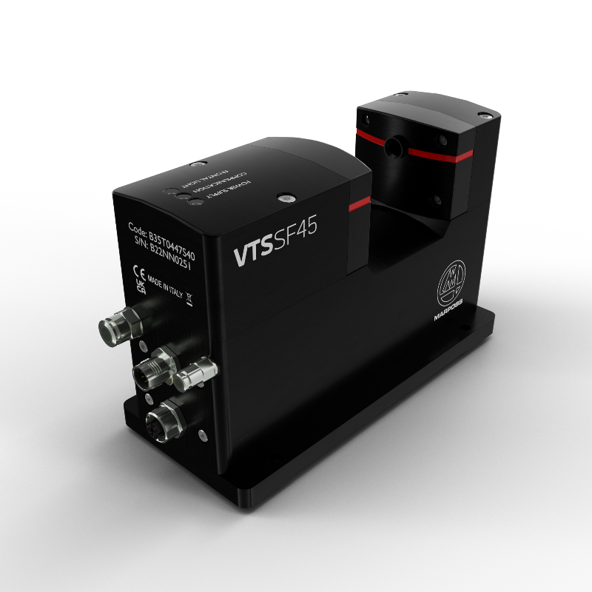

**Image description:** VTS.jpg -> Marposs new VTS SF-45 COMPACT